**9thInternational Petra School of Physics  
 “Nano Physics: Fundamentals and Applications”  
Amman, Irbid, Jordan  
October 9-12,2018**

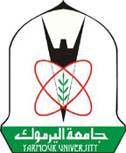



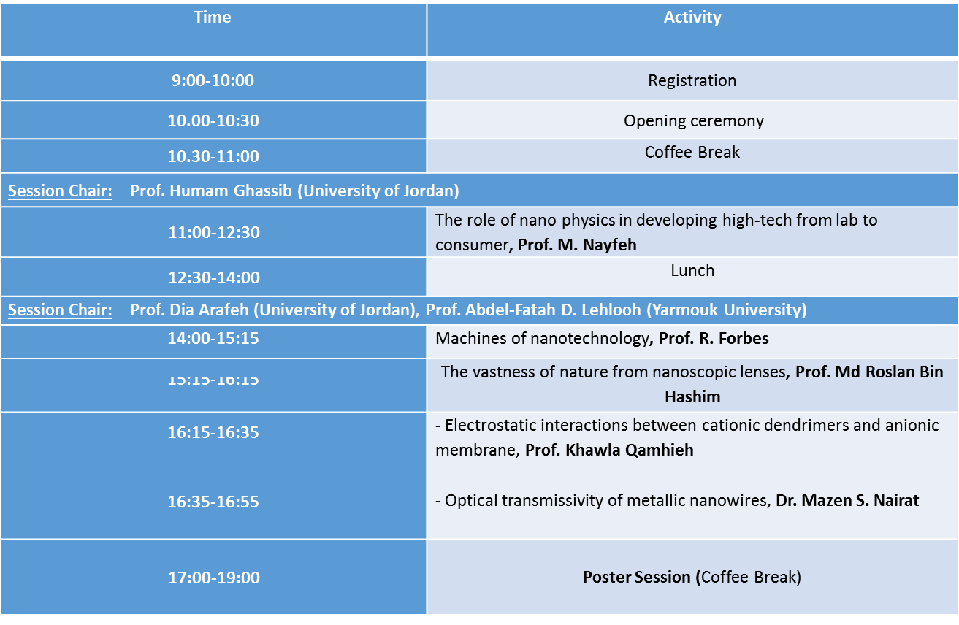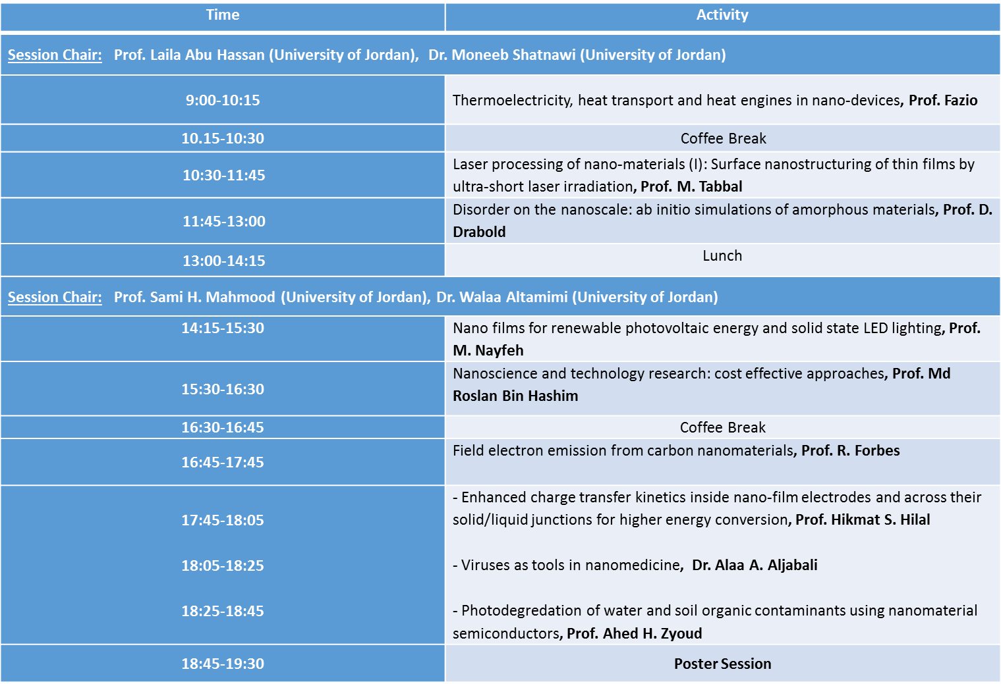

**SECOND DAY: Wednesday 10-10-2018**

**FIRST DAY: Tuesday 9-10-2018**

**Arrival: Monday 8-10-2018**

**Program**

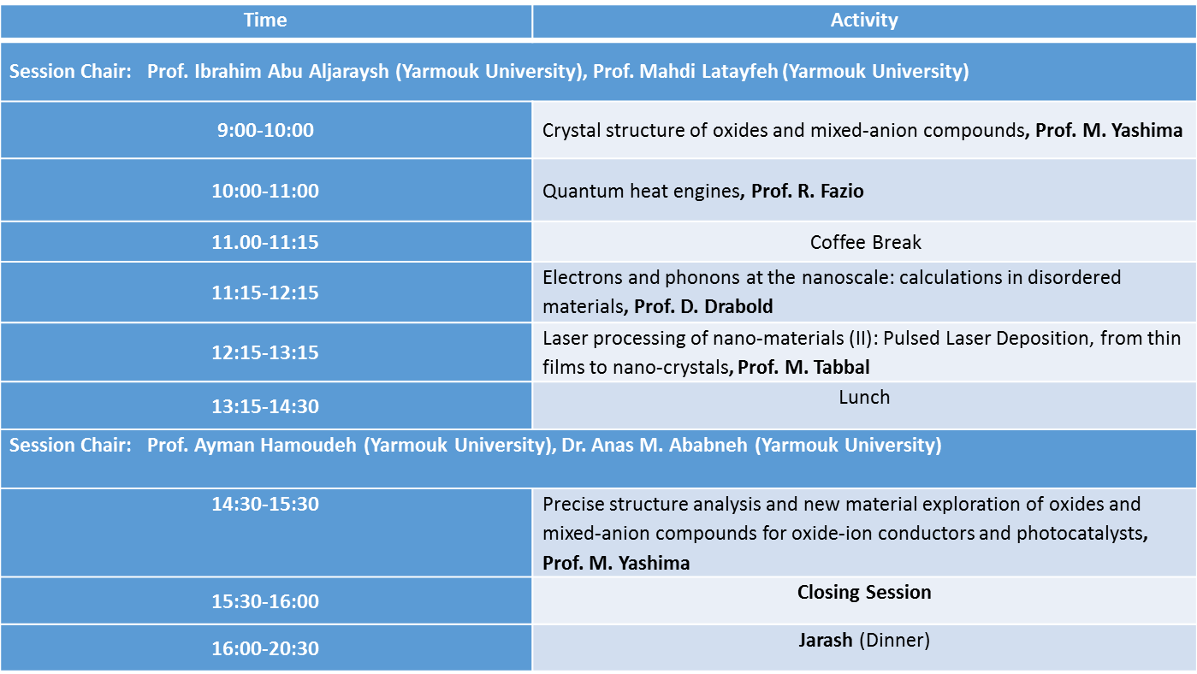

**THIRD DAY: Thursday 11-10-2018: Yarmouk University**

**FOURTH DAY: Friday 12-10-2018**