**9th International Petra School of Physics  
 “Nano Physics: Fundamentals and Applications”  
Amman, Jordan  
October 9-12 ,2018**

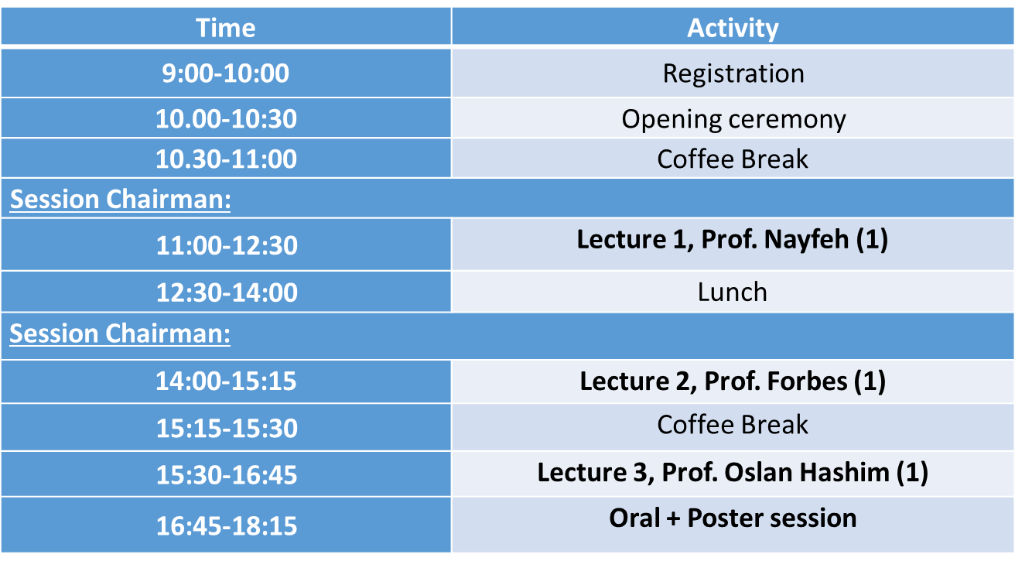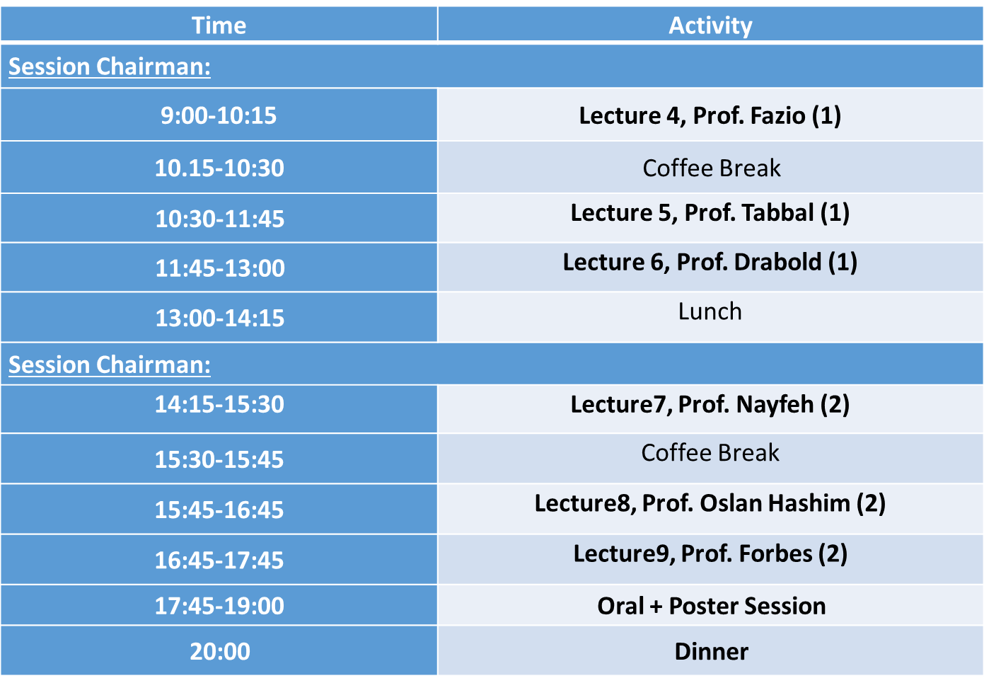

**SECOND DAY: Wednesday 10-10-2018**

**Tentative Program**

**FIRST DAY: Tuesday 9-10-2018**

**Arrival: Monday 8-10-2018**

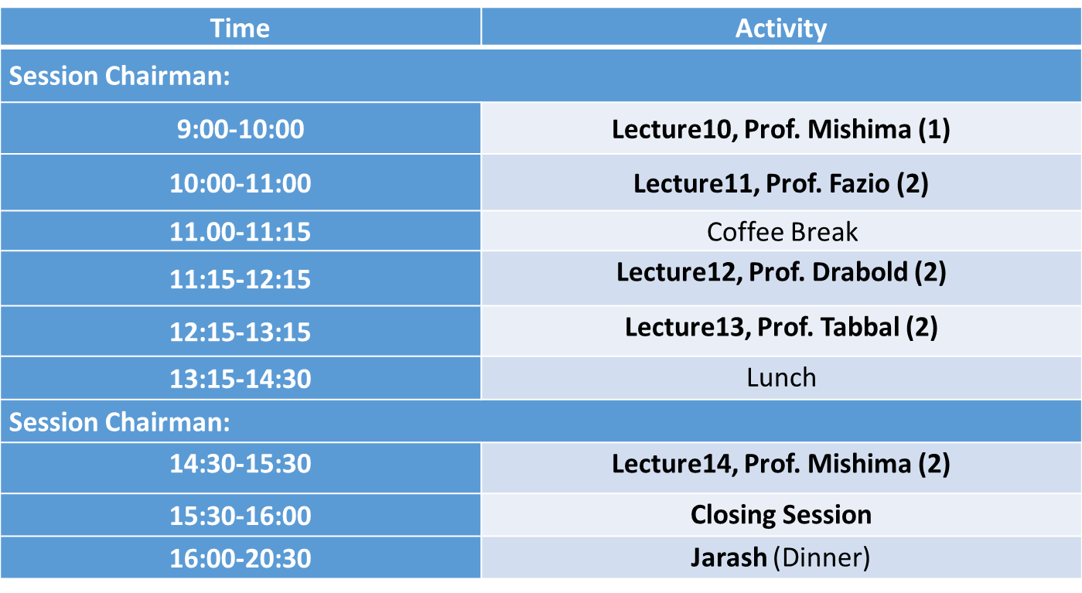

**THIRD DAY: Thursday 11-10-2018: Yarmouk University**

**FOURTH DAY: Friday 12-10-2018**