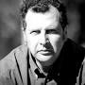
Prof. Rosario Fazio, The Abdus Salam International Centre for Theoretical Physics, Trieste, Italy.

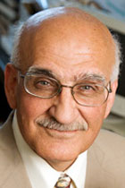
Prof. Professor Munir H. Nayfeh, University of Illinois at Urbana-Champaign.

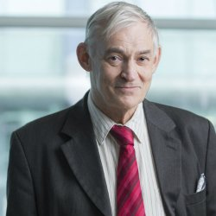
Prof. Richard G. Forbes, Surrey University, United Kingdom.

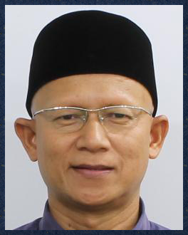
Prof. Md Roslan Hashim, Universiti Sains Malaysia, Malaysia.

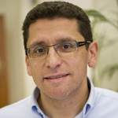
Prof. Malek Tabbal, American University of Beirut, Lebanon.

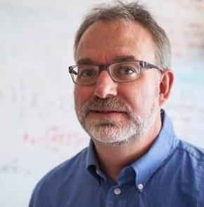
Prof. David A. Drabold, Ohio University, USA.

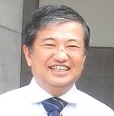
Prof. Masatomo Yashima, Tokyo Institute of Technology, Japan.

